Task 3

What is the level of measurement of the following variables?

1. The number of downloads of different bands’ songs on iTunes
   * Continuous/Discrete/Ratio
2. The names of bands that were downloaded
   * Categorical/Nominal
3. The position in the iTunes download cart.
   * Categorical/Ordinal
4. The money earned by the bands from the downloads.
   * Continuous/Ratio
5. The weight of drugs bought by the bands with their royalties.
   * Continuous/Ratio
6. The type of drugs bought by the bands with their royalties.
   * Categorical/Nominal
7. The phone numbers that the bands obtained because of their fame.
   * Categorical/Nominal
8. The gender of the people giving the bands their phone numbers.
   * Categorical/Nominal/Binary
9. The instruments played by the band members.
   * Categorical/Nominal
10. The time they had spent learning to play their instruments.
    * Continuous/Ratio

Task 4

Say I own 857 CDs. My friend has written a computer program that uses a webcam to scan the shelves in my house where I keep my CDs and measure how many I have. His program says that I have 863 CDs. Define measurement error. What is the measurement error in my friend’s CD-counting device?

Measurement error is the discrepancy found between what was measured and the true value. “There will often be a discrepancy between the numbers we use to represent the thing we’re measuring and the actual value of the thing we’re measuring (i.e., the value we would get if we could measure it directly). This discrepancy is known as measurement error.” (Field & Miles, 2012, p.11). In the CD program scenario, the discrepancy found between the actual value and measured value is 6 CDs.

Task 5

Sketch the shape of a normal distribution, a positively skewed distribution and a negatively skewed distribution.

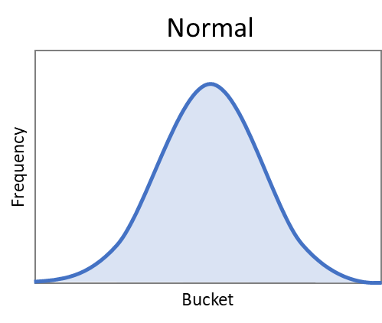

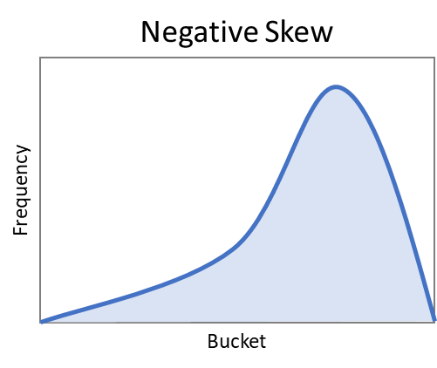

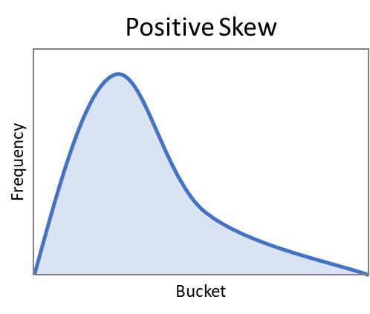

References

Field, Andy; Miles, Jeremy; Field, Zoe. Discovering Statistics Using R: Kindle Edition (p. 12). SAGE Publications. Kindle Edition.